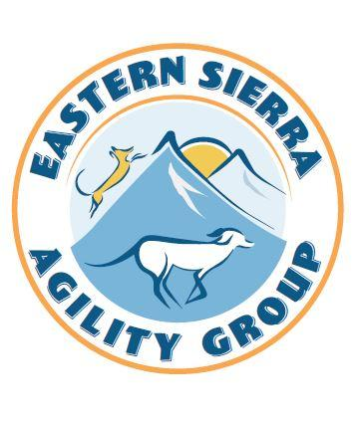
2023 ESAG Inc Trial Information
We welcome you back (or for the first time!) to the beautiful Eastern Sierra to play agility with our dogs! We will have a briefing each morning but wanted to also provide this handy summary of information for your reference.
Food:
Coffee, water and morning treats will be provided each day, and we have arranged for lunch delivery service each day of the trial and invite you to treat yourself while supporting local businesses. The menu for Saturday and Sunday can be found in the trial info section of our web site and we will have a few paper copies on hand as well. Please bring what you think you’ll need for the day as we’re a ways from town, although there is a convenience store/gas station less than 10 minutes away.
Friday: We will be purchasing some sandwiches (generous sized!) from the Crowley Lake Store. Options are roast beef, turkey, egg salad or a buffalo chicken wrap. $15 venmo or cash and includes a bag of chips and a soda. Please email Alix by Monday at 6 pm to guarantee your spot.
Saturday and Sunday: Our friend Miguel from Good Life Café in Mammoth will again be ensuring that we are well fed. Give your order to Alix each day by 10:30 a.m. CASH ONLY, paid to Miguel upon food delivery!
Other Services & Club/Trial Info:
Eastside K9 Hydrotherapy – https://www.eastsidek9hydrotherapy.com/ you may remember Debbi providing canine massage and laser therapy from our last trial. She’ll be back this year, offering therapy for your dogs AND running her new girl, Lexi! You can find her at the trial or contact her ahead of time if you have questions or want to schedule time for your dog.
Trial course maps, scores, etc. – will be posted on our web site as available: www.esaginc.org, or look around the trial site for our handy QR code that will take you right to our web site. Q and placement ribbons available by self-serve.
Volunteering & Payment Thereof – volunteers are essential to any enjoyable trial! We’ll be giving out tickets for volunteers who work classes and help course set, for our cash drawing. Returning will be the No Whining/Wine-ing drawing, to soften the blow of those NQ runs. And also: the High Winds, Low Stakes drawing: those who have their shade structures staked correctly will be given tickets for a chance to win local beer! Staking methodology to be reviewed during morning briefing.

Venue Info:
Please help us keep our beautiful site clean by picking up after your dogs. Dogs should be on leash near the rings but may be off-leash (under voice control of course) in the far corner of the baseball field, or the other two ball fields of the complex. We recommend leashing dogs while walking in the desert/undeveloped areas of the complex. Dogs are not allowed on the track or the soccer field in the middle of the track.
Critters: wildlife exists in the area! Ground squirrels, coyotes, deer, and occasionally a snake are all our neighbors at Whitmore, and bears, foxes, bobcats and mountain lions would be rare but possible. These animals are mostly leery of people, unlike in more urban areas, but your awareness and ‘social distancing’ is appropriate.
The field itself will have its gates closed at night and while we are in a very low-crime area, since there will not be anyone on site overnight, leave personal items at your own discretion.
We have two adjacent rings so that we can set and walk the next class while the current one is running. And, as in years past, we WILL be watering the field on Thursday night, so please do not set up anything that will be damaged if it gets wet. If you arrive on Thursday, please check in with a club member if you have any questions about parking or crating area set up.
Parking: Fire code requires that we leave the dirt road around the field completely clear for fire truck access, so please park off to the side of any dirt roads – and in this high drought year, please ensure any hot underparts of your vehicle are not in contact with dry plants.
General Eastern Sierra Safety Info:
Smoke … to some extent it’s the new normal in the Western U.S. Keep your fingers crossed, it’s been nice and clear this year!
Altitude … if you’re new to the area, note the trial site is at about 7,500 ft. above sea level. Please keep yourselves and your dogs hydrated and in the shade of your crating set-up, it’ll help lots! We haven’t had problems on-site with altitude sickness, but be aware (especially if you go hiking in the mountains) if you develop nausea or a headache that won’t go away, or if you feel lethargic or shaky. Those may all be signs that you need to move to a lower altitude.
Blue green algae – testing of various bodies of water has been performed in both Inyo and Mono counties this year; unfortunately, HAB has been found in several lakes although we are not aware of any local canine illnesses or fatalities reported. Please use your own best judgement especially at lower elevations, in water that is warmer and not fast-moving. This map is a great reference tool for finding recent HAB testing reports: https://mywaterquality.ca.gov/habs/where/freshwater_events.html

